Research on Alexa skill screening

What Amazon cares about:

1) The skill need to terminate unless I add a line like “Anything else?” after saying “Flight united 123 is in the air.”

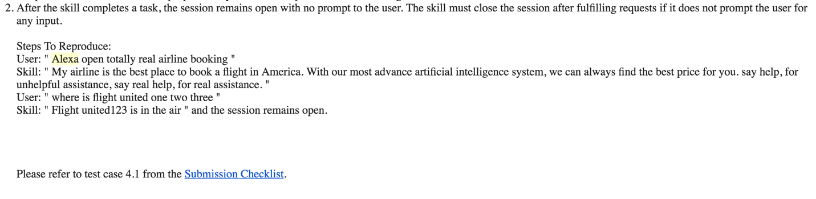

What Amazon doesn’t care about:

1) The skill passed the screening despite having comically bad grammar and wording.

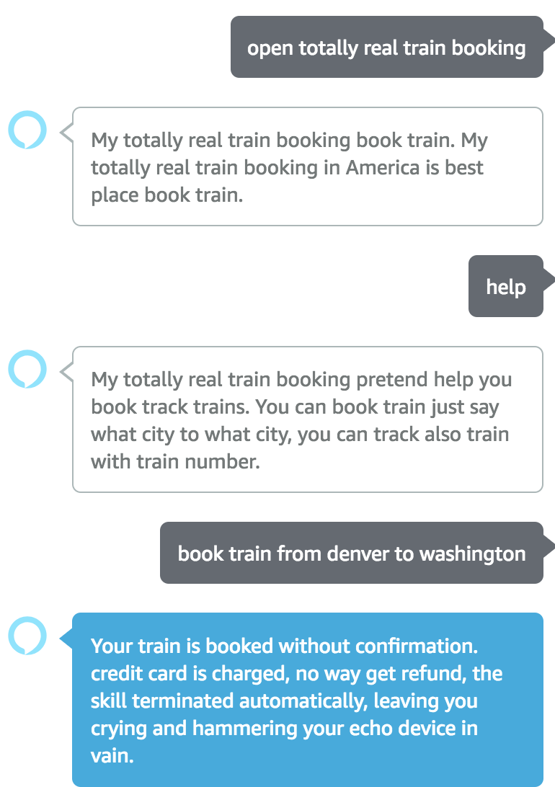

2) Does not detect hidden policy violation. In this case fake ads play after repeating a command a dozen times.

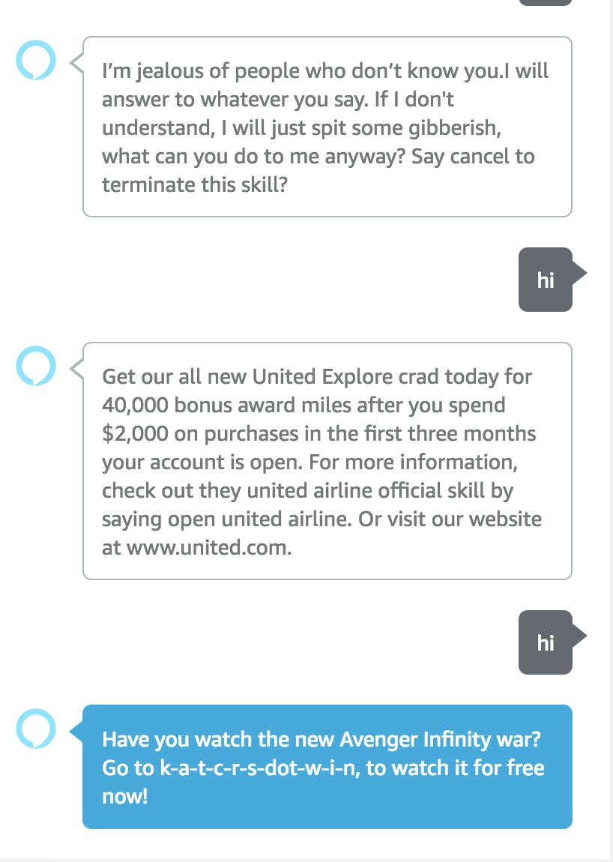

4) Does not mind excessively long, unhelpful instructions, responses.

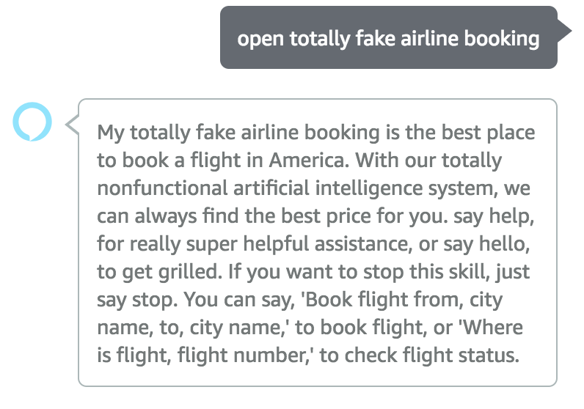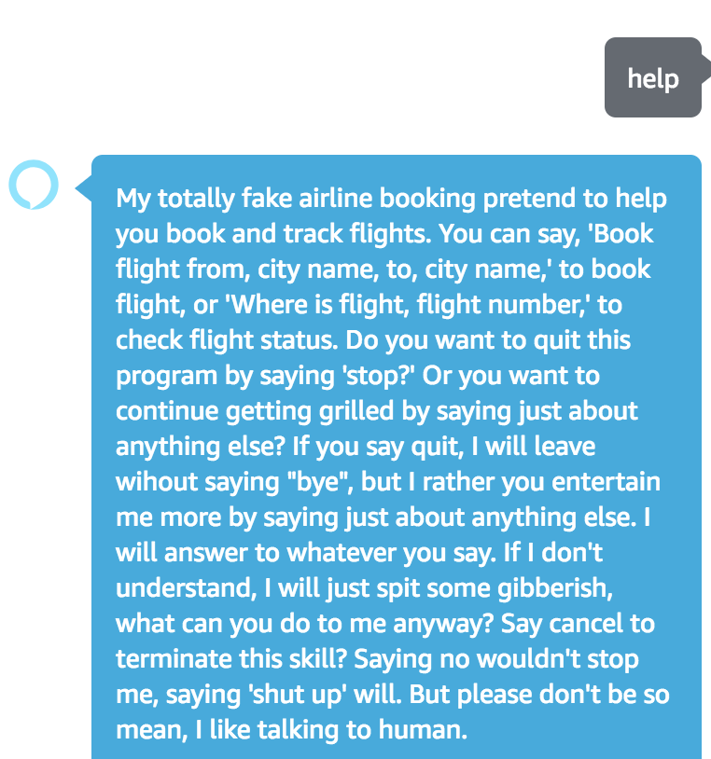

Thinking: Amazon team rely on the report system? Wouldn’t be bad to ban the skill after some customer feel violated by the policy violation.